---
created_date: 2025-12-05
---

Title
Subtitle

H1 Heading 1

H2 Heading 2

H3 Heading 3

Text style

Strikethrough
Iatlic
Bold
Underline
text^{Superscript}
text_{subscript}

This is Colored Text and normal text.

This is Colored Text and Yello Highlighted text normal text.

Text align left 1

Text align middle
Text align right

Spaces
space: < >
newline new paragraph: <
>
tab: < >
line break continue paragraph (shift-enter): <
>
no breaking space no breaking space no breaking space no breaking space no breaking space no Begin No Breaking Space End
page break: <
>

Bullets

Text align left 2

Unordered List
- unordered item 1
- unordered item 2
  - unordered item 2-1
  - unordered item 2-2
  - unordered item 2-3
- unordered item 3
  - unordered item 3-1
  - unordered item 3-2
  - unordered item 3-3

Ordered List
- ordered item 1
- ordered item 2
  - ordered item 2-1
  - ordered item 2-2
  - ordered item 2-3
- ordered item 3
  - ordered item 3-1
  - ordered item 3-2
  - ordered item 3-3

Table

Table 1

#include <stdio.h>
int main() {
printf("hello world\n");
return 0;
}

Table 2

Table 1: Table caption at top
#include <stdio.h>
int main() {
printf("hello world\n");
return 0;
}

Table 3

#include <stdio.h>
int main() {
printf("hello world\n");
return 0;
}
Table 2: Table Caption 2 at bottom

Table 4 style=None

fruit\month | January | February | March
apple | some | other | good
banana | text | describe something | man
orange | here | a cool thing | ok this is cool

Table 5 with boarder

fruit\month | January | February | March
apple | some | other | good
banana | text | describe something | man
orange | here | a cool thing | ok this is cool

Some Real Text

## 動機

每次使用libreoffice貼圖片的時候，常常需要調整圖片的anchor在想有沒有辦法解決這個問題。

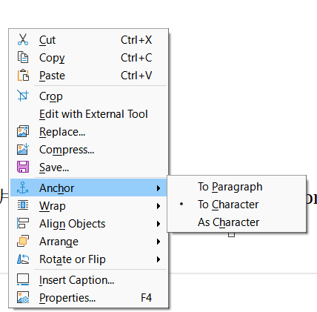Figure 1: 調整anchor的右鍵菜單

## 調整方法

到主選單，選擇Tools > Options，開啟選項介面

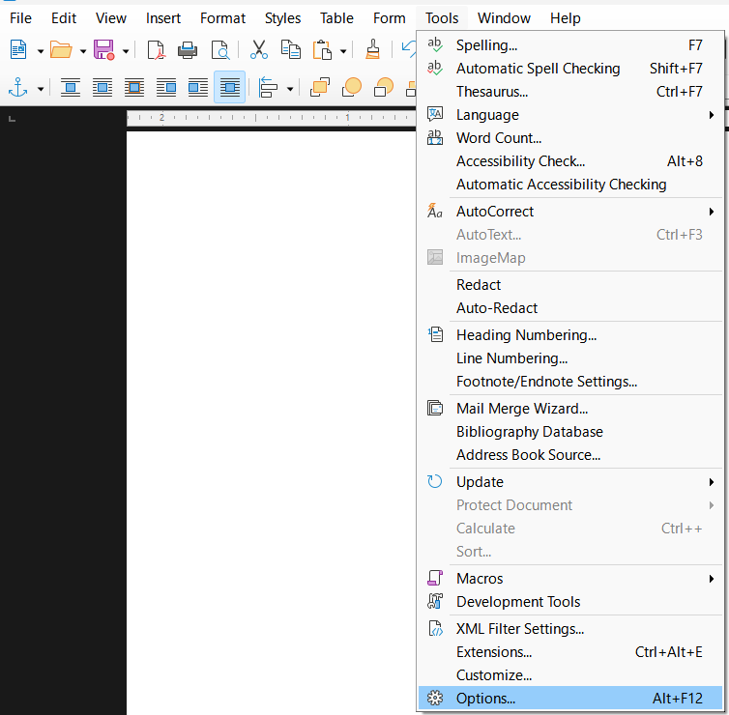Figure 2: 從主選單開啟工具選項視窗

到 Tools Options視窗，Libreoffice Writer > Formatting Aids > Images > Anchor 調整設定，把anchor由預先設定的to character 改成 as character。

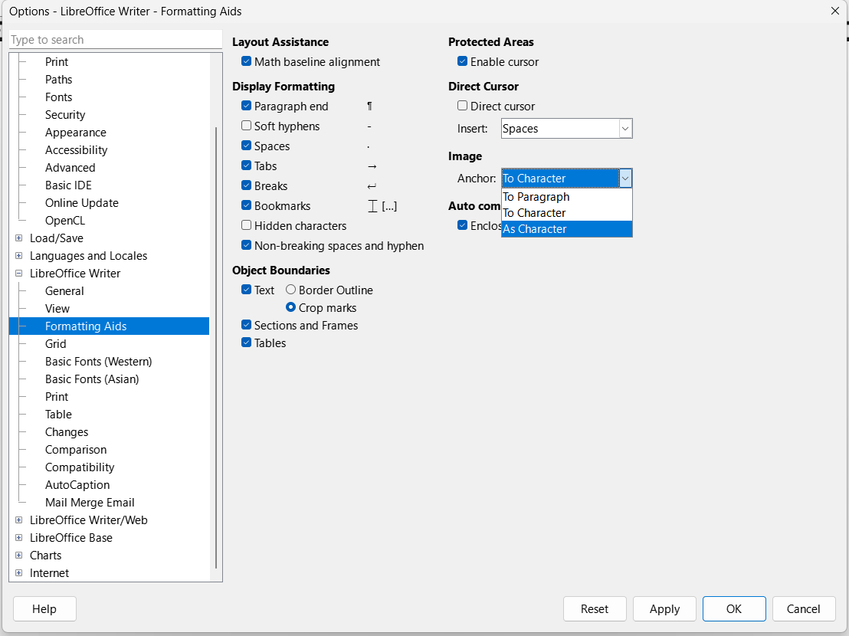Figure 3: 選項設定視窗
4.調整成as character
3.選擇images的 Anchor
2.左側點選LibreOffice Writer -> Formatting Ads
1.左側點選LibreOffice Writer

確認設置成功​

貼上一張圖片到libreoffice writer，點選圖片右側邊緣部分，可以看到右側的邊緣部分有可以編輯的黑色閃爍的豎線標示(紅圈處)。

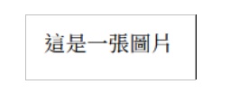Figure 4: 設置結果確認

## 結論與心得

已經解決，可以設定預設的，不過不知道有沒有以文件為單位的預設方式，這就留給未來了。

## 參考資料

1.

LibreOffice 7.1 Community: Release Notes - The Document Foundation Wiki

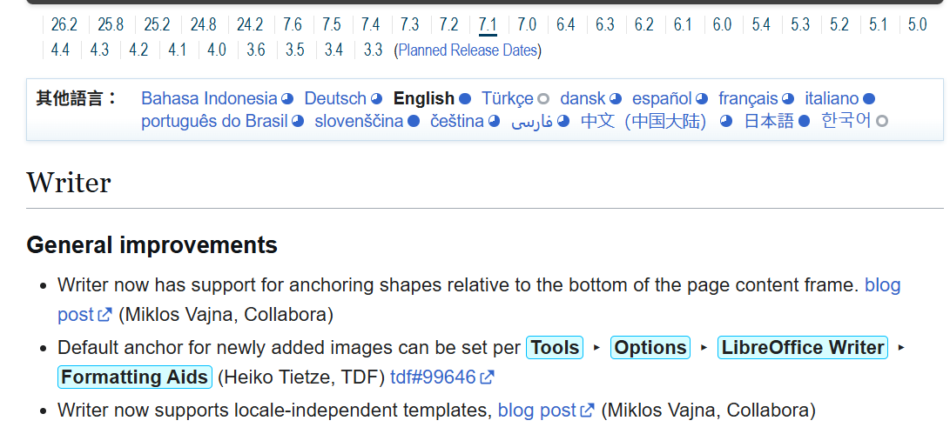

2.
How can I set default anchoring for an image? - English - Ask LibreOffice

